  - Organizations in the asphalt industry navigate a multifaceted and complex business environment. In addition to accounting and customer management, users in the asphalt industry need a system that can manage estimates, project management, change orders and many other tasks related to this industry. Typically, one system cannot handle all these functions and they must be done in several different systems making an integration challenging and difficult for the user.
  - Acumatica Construction Edition is a scalable, true cloud ERP application with included CRM and available inventory management and field service modules and integration to top-tier construction management and estimating programs. The multi-level process in the asphalt industry is handled seamlessly in Acumatica with the help of some configurations fit for this industry. Acumatica works for taking asphalt products from the scale and turning them into cash.

The process in Acumatica for Asphalt Products:
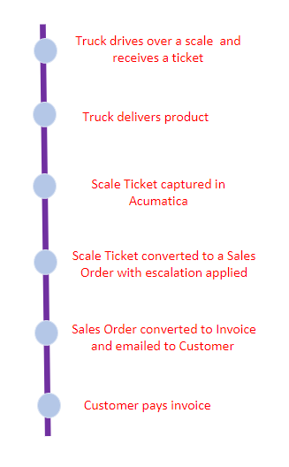
  - Although the process for taking an asphalt product from the lot, over a scale and turning it into cash might differ slightly for each company, there are similar steps to complete no matter your company. Using Acumatica streamlines this process with a set of recurring processes for each step. Seen in the image is the typical process from start to finish, dropping off the asphalt product on site and turning it into cash with a payment from the customer. Each of these steps in the lifecycle of drop off to getting paid for the order is made easier and more efficient with Acumatica. Let’s review these steps in more detail and how Acumatica makes the user experience better.
- Truck runs over a scale and receives a ticket with information such as product and quantity to be delivered
- A truck drops off a product
- With the Polaris Asphalt Solution, the scale tickets will be captured in Acumatica without double entry. In addition, you don’t have to worry about lost tickets or wait for the driver to come back with the paper scale ticket. With Acumatica, processes become more streamlined and less reliant on paper.
- With the Polaris Asphalt Solution, the sale ticket can be converted to a sales order and have the proper asphalt price index applied to ensure more accurate invoicing.
- With just a couple of clicks, the sales order is converted to an invoice. There is no need to re-enter data into the system since the scale ticket has already created the sales order. Users can print and/or email the invoice to the customer without leaving the invoice screen. Email and printing settings and preferences can be set up for each customer in Acumatica ensuring that the customer receives the invoice in the method they prefer.
- In Acumatica, users can enter payment to close the invoice.
  - With Acumatica and our Polaris Asphalt Solution, we are easily able to take scale tickets, apply proper pricing, send the invoice, and receive payment with minimum data entry and increase accuracy and speed.

Acumatica’s Full Financial Module:
  - Acumatica Financial Management is loaded with best-in-class accounting applications to manage your entire organization on a single platform. Financial Management is the heartbeat of every Acumatica edition, including construction and projects, which is vital to an asphalt company like yours. Connected project accounting and customer relationship management close the loop, just like the lifecycle above, providing project-driven companies with real-time financial insights.
  - Asphalt companies need a real time, holistic view of their company to ensure things are running smoothly and they are providing the best service they can. Acumatica provides a complete picture of your financials anywhere, anytime, on any device allowing users to see information both in the field and in the office, vital to project-based companies. Generating reports of information and configurable, drillable dashboards make Acumatica unique and allows users to see business performance in real time.
  - With Acumatica, users in the asphalt industry can automate and simplify several of their business processes. Scale tickets, sales orders and invoices are easily managed in one system making the process for project quoting and invoicing revamped and simplified. The integration of a scale ticket system to Acumatica allows companies to bill faster, improving the length of time it takes to get paid. Acumatica’s embedded dashboards, reporting, and inquiries bring the system together with real-time analytics for those who need them.

Take the Next Steps Toward a New ERP
  - Connect to top-tier construction management and invoicing tools for best-in-class functionality for your asphalt business. A single, cohesive platform configured to meet your organization’s complex and evolving business needs will take your business to the next level.
  - Acumatica can be what your company needs to become great! To learn more about Acumatica and request a free demo – visit us online!
  - Polaris Business Solutions would love to help you find the right ERP system to suit your needs for your asphalt business. You can find more helpful information about Acumatica, Polaris Business Solutions and more at www.polaris-business.com.

