  - Acumatica cloud-based ERP software solution is a comprehensive modern ERP with multiple modules to fit your growing business needs. Specific to industry needs, Acumatica Construction Edition is suited for growing construction companies with needs that include built-in CRM, field service monitoring, project budgeting and costing, mobile access, and inventory management. The platform is user friendly and has robust financial management and project costing for your business. The project costing process within Acumatica is simple, streamlined, and completed in one system.
  - The financial portion of the Construction Edition in Acumatica is very robust. Within the module, users can manage GL/AP/AR, run real-time reports on materials and equipment, easily manage daily field reports, capture time and expenses for projects, manage inventory, and many other important items to manage a successful project-based business. The following process reviews the steps of project costing in Acumatica and its benefits.

Quote to a Project in Acumatica
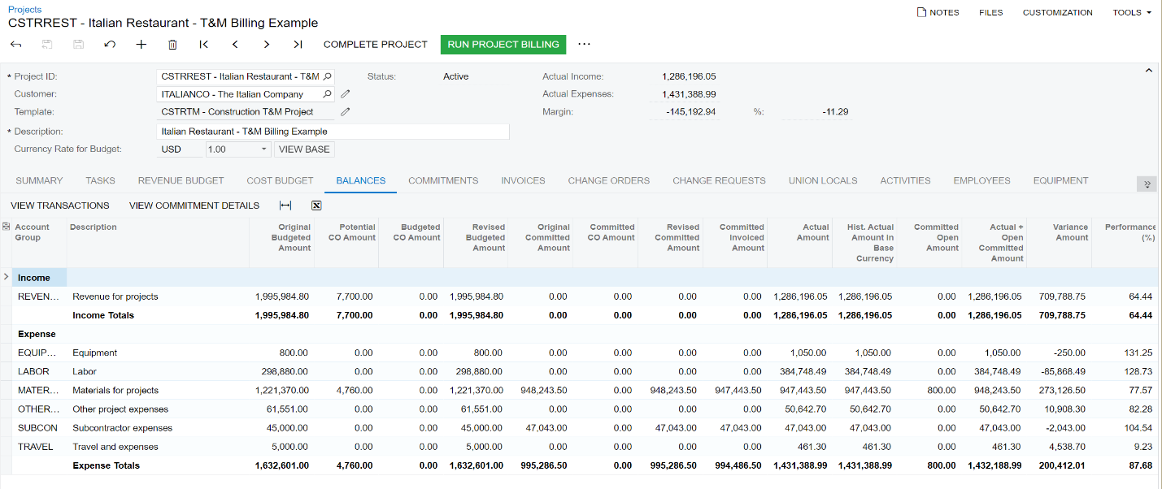
  - Creating a quote in Acumatica starts the process of capturing all relevant information for a project in Acumatica. Information such as address, billing method, project manager and other project specific data are entered into the quote. Specific to the asphalt industry, Acumatica can house data in the project quote such as asphalt price index. Once a quote is approved by the customer, it can be converted to a project with just a couple of clicks.
  - The project screen in Acumatica has all the information related to a quote previously done including the asphalt price index. This screen provides a one stop shop for all information related to a project. As seen on the screen shot above, users can access information such as change orders, commitments, invoices and more all in the same screen. This is a powerful tool for Acumatica and a great benefit for construction users who can use this screen to get more information about the costs of the project.

Costs of a Project in Acumatica
  - Companies like yours typically use more than one system in tandem with their accounting system to manage their asphalt business. Systems that aren’t integrated can bring added costs to the company. The beauty of an all-in-one system eliminates the need for multiple systems to be integrated to complete a single task.
  - With Acumatica, users in the Asphalt industry can connect all aspects of their business, including sales, inventory, materials management, project management, payroll, finance, and service management. This not only increases everyone’s visibility into business processes, but also reduces the need for tedious data entry.
  - 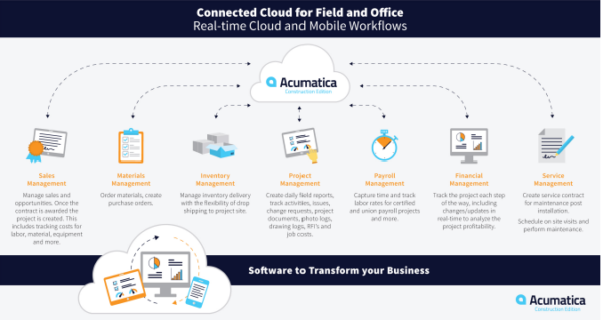

Dashboard and Reporting
  - Every kind of company— construction, financial, manufacturing - relies on measurements to monitor business activities and performance, document successes and challenges, and help direct management decision-making. Of course, we measure several parameters simply to comply with mandatory accounting and reporting requirements, and smart management will incorporate those measurements into valuable intelligence. Specific to the asphalt industry, dashboard and reporting can be built to quickly view metrics on the front screen on Acumatica.
  - Dashboards offer drill-down for analysis of the details and can be adapted to provide key measurements to individual departments or functions within the organization, focused on the specific measurements that are important in their individual span of interest. In the asphalt industry for example, the project manager may be interested in seeing the active projects or the change order log. See below for an example:
  - 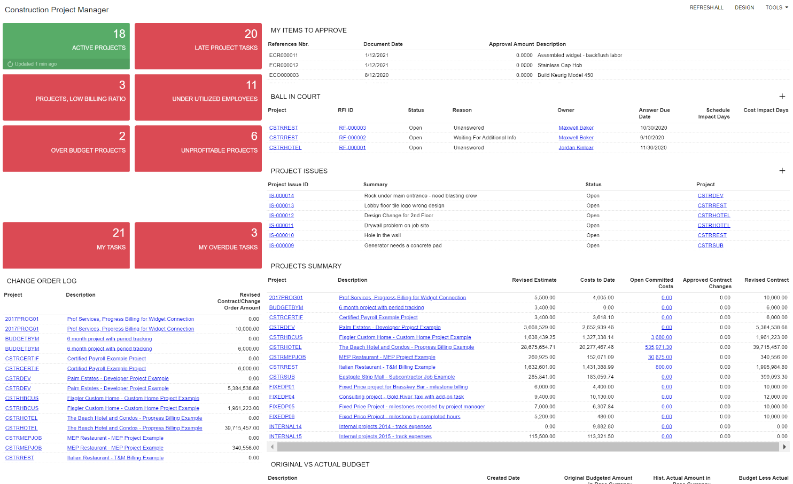
  - Reporting in Acumatica is a vital tool to see the data in one big picture. Acumatica comes with over 250 reports out of the box which can give users a great start to running reports without any add-ons. These reports are configurable to your industry data. The data in dashboards and reporting is in real-time making these analytics up to date for those who need to see them.

Benefits of Acumatica for your Asphalt Business
  - With Acumatica, users in the asphalt industry can automate and simplify several of their business processes. Project budgeting, inventory and change orders are easily managed in a single system making the process for project quoting and invoicing revamped and simplified. The integration of timesheets and billing allows companies to bill faster, changing the length of time it takes to get paid. Acumatica’s embedded dashboards, reporting, and inquiries bring the system together with real-time analytics for those who need them.

Take the Next Steps Toward a New ERP
  - If your company is ready to take the next steps and see how Acumatica is suited for the asphalt industry, do not stop here. Acumatica is an all-in-one accounting and project package that will connect users in the field and your office staff.
  - To learn more about Acumatica and request a free demo – visit us online!
  - Polaris Business Solutions would love to help you find the right ERP system to suit your needs for your asphalt business. You can find more helpful information about Acumatica, Polaris Business Solutions and more at www.polaris-business.com.

