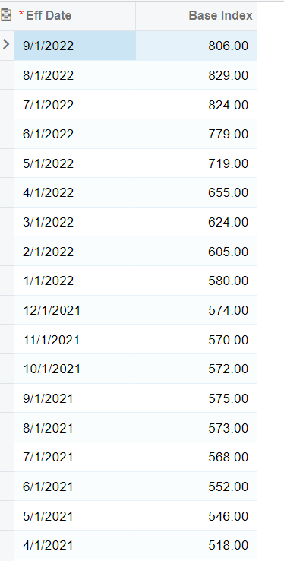
  - Polaris Business Solutions has worked to build functionality specific to the price index formulas for the asphalt industry within Acumatica. This functionality has allowed users to see the agreed upon pricing while factoring in the current price index of the industry to create a standard pricing functionality within Acumatica. The changes to the price index can be stored within Acumatica. This will help to streamline the quoting, invoicing, and revenue recognition process that are affected by price index in Acumatica.

Preparing the Quote
  - To begin, the first step is to create a project quote within Acumatica.
  - 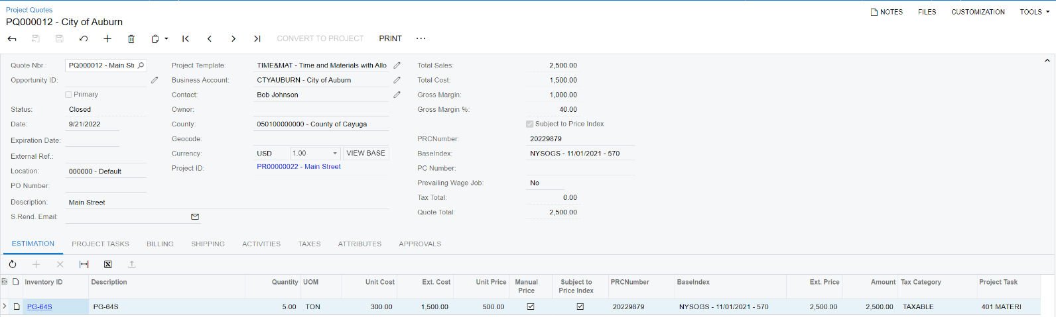
  - When creating a quote in Acumatica, users will select a business account that will include all the details for the customer including contact information, location, address, and billing information. In addition, the user will select base index and other relevant information related to the bid.

  - On the estimation tab users will then enter more information including:
- Inventory Item
- Quantity
- Unit Price
  - Once the quote is approved by the customer, the user will convert the quote to a project.

Reviewing the Project
  - On the projects screen, users can see all information from the project quote in a single screen. In addition, the location, budget, billing settings, change orders, and equipment required for the specific project can be visible on this screen.
  - 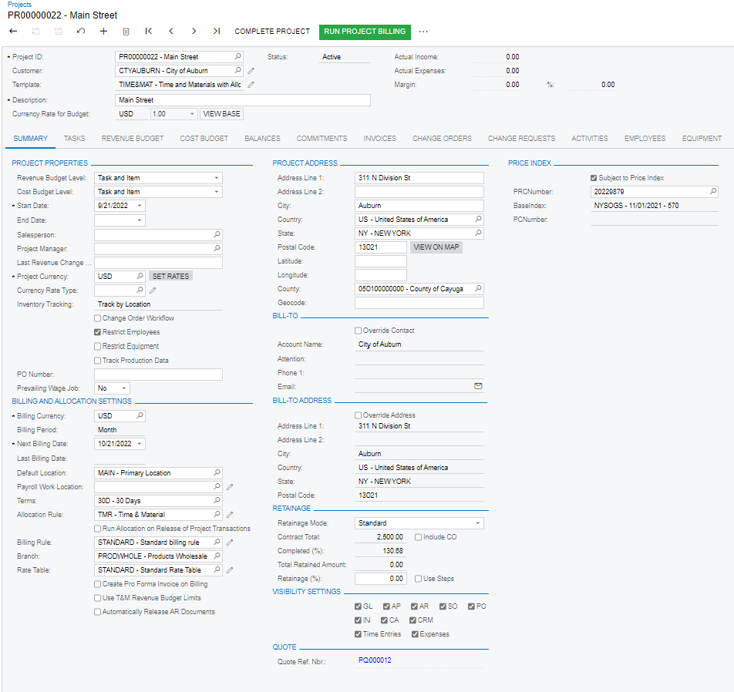
  - On the revenue budget tab users can see the information related to the project task associated with this inventory ID. This line item will show the original budgeted amount and quantity and well as the revised quantity and amount. The invoice amount will be calculated to account for the price index.
  - Creating an Invoice
  - Next, the user will create an invoice for the product(s) that were used for the project. The user will enter in the quantity of the product to be billed and the quantity will be updated from an integration with a scale system.

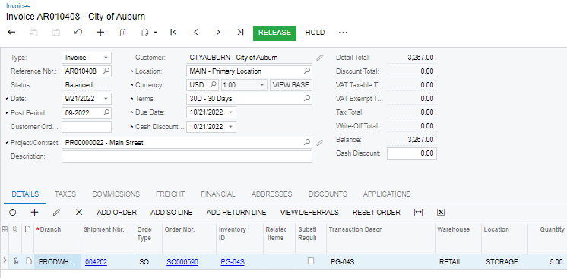

  - The calculation considers the current index (based on the invoice date), base index and the percent asphalt of that product on the invoice. This information is held within Acumatica and used to calculate the index adjusted as shown below. In the screenshot below, the index adjustment will show the amount of any escalation or de-escalation.
  - 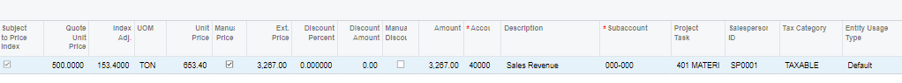

  - Taking the Next Steps Toward Your Cloud ERP
  - If your company is ready to take the next steps and see how Acumatica is suited for the asphalt industry, do not stop here. Acumatica is an all-in-one accounting and project package that will connect users in the field and your office staff.
  - To learn more about Acumatica and request a free demo – visit us online!
  - Polaris Business Solutions would love to help you find the right ERP system to suit your needs for your asphalt business. You can find more helpful information about Acumatica, Polaris Business Solutions and more at www.polaris-business.com.

